Progress Monitoring Pasco eSchool Canvas courses

Choose the myLearning APP from your dashboard

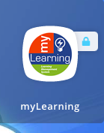

CLICK “Admin” from the options on the left and then “Pasco eSchool Secondary Program 2020-21”

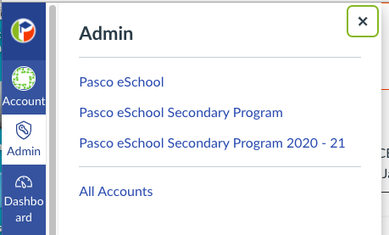

Click “People” from the options on the left
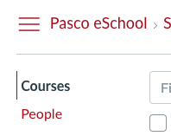

Type in the student’s name and then click the student name when it pops up

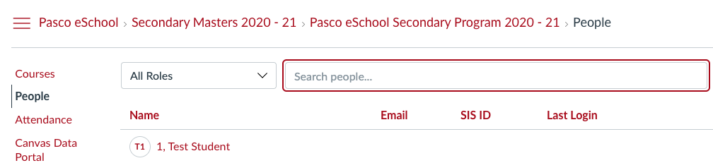

Scroll through enrollments and click the course that you are checking on

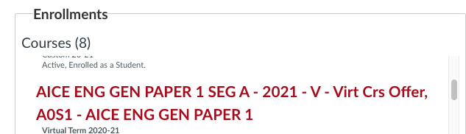

Click “Student Grades” on the right

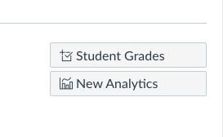

Updated 1/25/21

